Interpreting ANOVA results
[borwick2001]
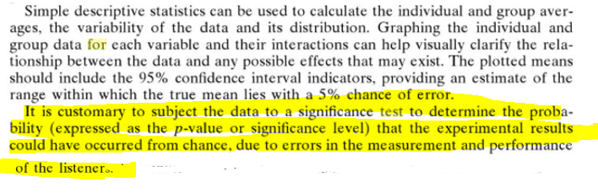
A listener’s performance can be quantitatively measured by statistically analysing their listening test data. By performing analysis of variance (ANOVA) on each individual listener’s data, the error variance and F-statistic scores can be computed to establish who are the most discriminating and reliable judges of sound quality

[zach2006]

Interpreting Box plots
The box plot (also called a box- and-whisker plot) provides a quick overview of the distribution of the data including outlying and extreme observations. The box represents the range occupied by 50% of the observations plus an indication of the median. If the median is in the middle of the box, it indicates a symmetrical distribution and the standard mean value can be used instead. Observations more than 1.5 times the box length from the 25% or 75% percentile, termed outliers, are marked and hence are extreme observations corresponding to more than three times the box length from the 25% and 75% percentiles. The box plot in Figure 6.6 shows, as expected, that the distribution is symmetrical and that there are no outliers.
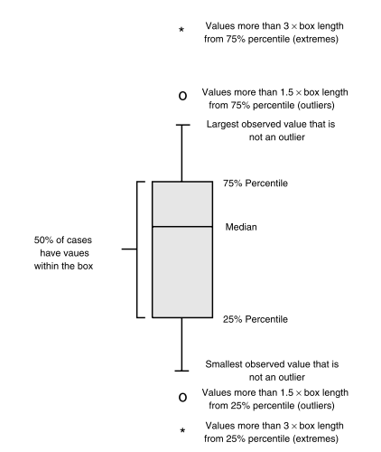
(Description of the different parts of a box plot, from [bech2006])
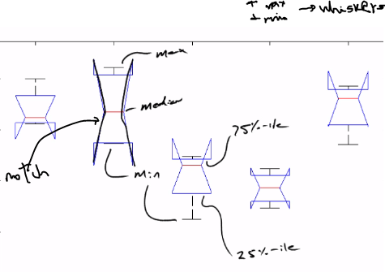
Also the top and the bottom of the angled lines have significance as they represent the upper confidence limit and the lower confidence limit, so the 95% confidence interval of the median (we are 95% confident that the true median value for the listener rating (for each listener) ranges from the upper circle to the lower circle:
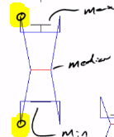 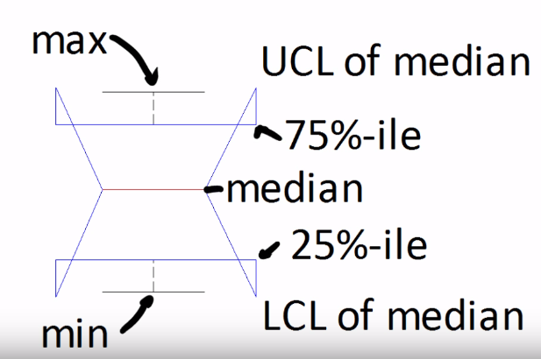
[https://www.youtube.com/watch?v=gyccXv1NiOw]

Interpreting anova tables
Row | Definition
Groups | Variability due to the differences among the group means (variability between groups)
Error | Variability due to the differences between the data in each group and the group mean (variability within groups)  Per questo faccio il test dei residui se voglio controllare l’assunzione di normalità!

Matlab:
The ANOVA table shows the between-groups variation (Columns) and within-groups variation (Error).
In python: columns -> C(treatments)
Error -> Residual
$SS$ is the sum of squares, and $df$ is the degrees of freedom. The total degrees of freedom is total number of observations minus one, The between-groups degrees of freedom is number of groups minus one. The within-groups degrees of freedom is total degrees of freedom minus the between groups degrees of freedom.
$MS=\frac{SS}{df}$ is the mean squared error for each source of variation. The F-statistic is the ratio of the mean squared errors (MS_columns/MS_errors).
The p-value is the probability that the test statistic can take a value greater than the value of the computed test statistic, i.e., P(F > F_column).
A small p-value (such as 0.0023) indicates that differences between column means are significant
DA PAG.191 A PAG.193 PER CAPIRE LE FORMULE

[Fazenda2015] EXAMPLE
Example of why ANOVA: we want to rate 4 loudspeakers in terms of perceived quality
Rating scores between 0 and 10 in steps of 0.1 with 6 listeners on 4 loudspeakers
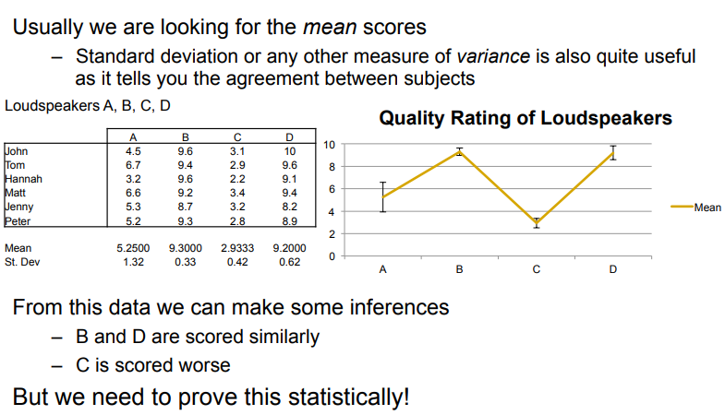
The ANOVA checks the hypothesis that all means are the same (for the 4 loudspeakers)
Can be run in excel (or Matlab, SPSS, R, etc)
It gives a percentage probability that they all belong to the same population. This is output in P-value in the table
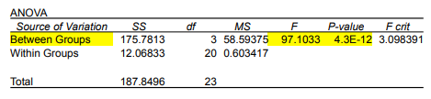
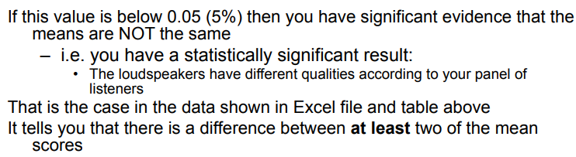
The ANOVA has suggested a significant effect for loudspeakers But it only tells you that at least one loudspeaker is scored significantly different from the others But how do we tell if there is a difference, say, between B and D?
If you want to find out which particular scores are significantly different you would need to run a series of paired comparisons I.e. you run a stats analysis for each paired combination in your test One option is the t-test (but this needs to be corrected!)
Example of WHY T-TEST
In our loudspeaker example, you have a single factor (loudspeakers) – So you have done a one way anova
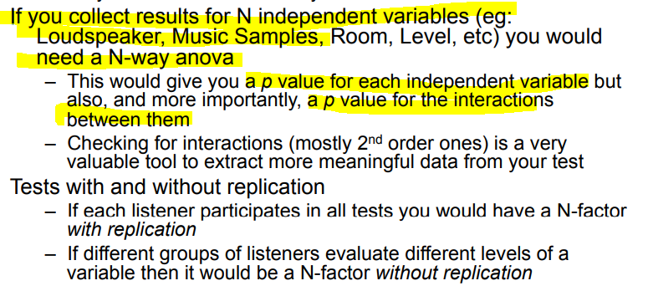

[herre2015] More statistically speaking
(Statistical methods for audio experiments)
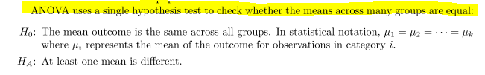
The method of analysis of variance (ANOVA) in this context focuses on answering one question:
is the variability in the sample means so large that it seems unlikely to be from chance alone? This question is different from earlier testing procedures since we will simultaneously consider many groups, and evaluate whether their sample means differ more than we would expect from natural variation.
Think about the question: "Are the group means different?" You are implicitly asking about the variability of the means. After all, if the group means don't vary, or don't vary by more than random chance allows, then you can't say the means are different. And that's why you use analysis of variance to test the means.

IN OUR CASE ONE WAY WOOFER/TWEETER
(Interpreting one-way ANOVA)

Understanding p-value
The null hypothesis states that the population means are all equal. Usually, a significance level (denoted as α or alpha) of 0.05 works well.
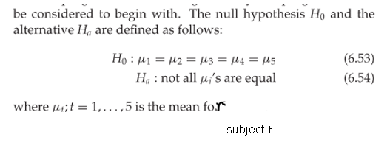

___________________________ (IN OUR EXAMPLE) _______________
The rationale behind the ANOVA is the same as that for the t-test: Compare the deviation between the sample means of the treatments to the random deviation within the samples and test whether the magnitude of the ratio is higher than a certain critical value [bech2006].
•The deviation between sample means of the treatments is, IN OUR EXAMPLE, the deviation related to differences between the mean values of the listener ratings. The deviation between the listener ratings mean values is often termed between-groups deviation (mi muovo per colonne).
•The random deviation is the deviation caused by the repeated ratings for each loudspeaker track combination on the same attribute (mi muovo per riga sulla stessa Colonna). The deviation related to the repeated ratings for each listener is often termed within-groups (or error deviation).
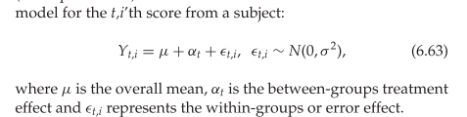

NELL’ATTRIBUTO 1, 2 OPPURE 3, QUANTO INFLUISCE IL SOGGETTO (ONE WAY: we are assuming (studying) it is the only factor can make the ratings (means) different) SUL RATING (UNIVARIATE: number of dependent (outcome) variables involved) PER QUELL’ATTRIBUTO
INDIPENDENTEMENTE DALLA TRACCIA O DALLO SPEAKER
(altrimenti se mi fossi dovuto trovare l’influenza di speaker/soggetti -> two way)
One-way anova has a single independent variable (IV which is categorical/nominal, as you indicate) having two or more levels, and a single, metric (DV, interval or ratio strength scale) dependent variable. One-way manova has a single IV and two or more metric DVs
NEL LISTENING TEST SEMPRE UNIVARIATE PERCHE’ STO ANALIZZANDO IL RATING

E’ GIUSTO PERCHE’ E’ COME L’ESEMPIO DI [bech2006]
The ANOVA checks the hypothesis that all means are the same (for the 4 loudspeakers) giving a percentage probability that they all belong to the same population. This is output in P-value in the table
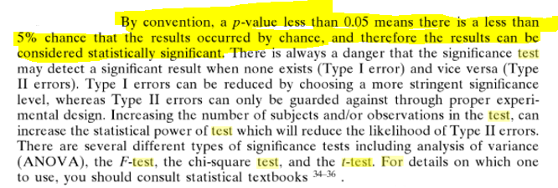
[borwick2001]
• If the p-value $≤α$, you reject the null hypothesis and conclude that not all of population means are equal.
• If the p-value$>α$ you do not have enough evidence to reject the null hypothesis that the population means are all equal

Understanding F-value IN ONE WAY ANOVA + ALTRI VALORI TABELLA
[https://blog.minitab.com/blog/adventures-in-statistics-2/understanding-analysis-of-variance-anova-and-the-f-test]
F-tests are named after its test statistic, F, which was named in honor of Sir Ronald Fisher. The F-statistic is simply a ratio of two variances. Variances are a measure of dispersion, or how far the data are scattered from the mean. Larger values represent greater dispersion. Variance is the square of the standard deviation. F-statistics are based on the ratio of mean squares. The term “mean squares” may sound confusing but it is simply an estimate of population variance that accounts for the degrees of freedom (DF) used to calculate that estimate. Despite being a ratio of variances, you can use F-tests in a wide variety of situations. Unsurprisingly, the F-test can assess the equality of variances. However, by changing the variances that are included in the ratio, the F-test becomes a very flexible test. For example, you can use F-statistics and F-tests to test the overall significance for a regression model, to compare the fits of different models, to test specific regression terms, and to test the equality of means.
To use the F-test to determine whether group means are equal, it’s just a matter of including the correct variances in the ratio. In one-way ANOVA, the F-statistic is this ratio:
F = variation between group means / variation within the samples
The best way to understand this ratio is to walk through a one-way ANOVA example.
NUMERATOR = variation between sample (group) means
One-way ANOVA has calculated a mean for each of the four group (loudspeaker). The group means are: 11.203, 8.938, 10.683, and 8.838. These group means are distributed around the overall mean for ALL 40 observations, which is 9.915.
If the group means are clustered close to the overall mean, their variance is low. However, if the group means are spread out further from the overall mean, their variance is higher.
Clearly, if we want to show that the group means are different, it helps if the means are further apart from each other. In other words, we want higher variability among the means.
What value do we use to measure the variance between sample means for the plastic strength example? In the one-way ANOVA output, we’ll use the adjusted mean square (Adj MS) for Factor, which is 14.540. Don’t try to interpret this number because it won’t make sense. It’s the sum of the squared deviations divided by the factor DF. Just keep in mind that the further apart the group means are, the larger this number becomes.
(SEE “INTERPRETING ANOVA TABLES” ABOVE)
DENOMINATOR = variation within the samples
We also need an estimate of the variability within each sample. To calculate this variance, we need to calculate how far each observation is from its group mean for all 40 observations! Technically, it is the sum of the squared deviations of each observation from its group mean divided by the error DF. If the observations for each group are close to the group mean, the variance within the samples is low. However, if the observations for each group are further from the group mean, the variance within the samples is higher.
The more spread out the observations are from their group mean, the higher the value in the denominator of the F-statistic

If we’re hoping to show that the means are different (reject the null-hypotesis), it's good when the within-group variance is low (ratings molto raccolti per ogni ascoltatore)**. You can think of the within-group variance as the background noise that can obscure a difference between means
For this one-way ANOVA example, the value that we’ll use for the variance within samples is the Adj MS for Error, which is 4.402. It is considered “error” because it is the variability that is not explained by the factor.

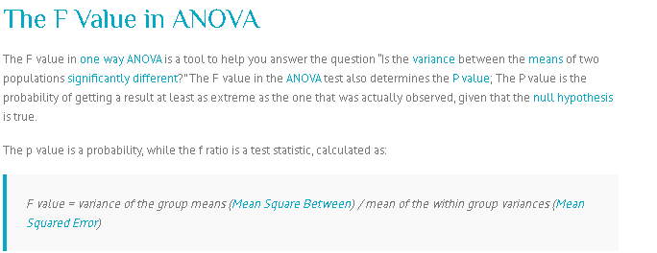

Relazione tra F-value e p-value (significato statistico)
For one-way ANOVA, the ratio(F-statistics) of the between-group variability to the within-group variability follows an F-distribution when the null hypothesis is true (graph displays distribution of F-values that we'd obtain if the null hypothesis is true)
Because the F-distribution assumes that the null hypothesis is true, we can place the F-value from our study in the F-distribution to determine how consistent our results are with the null hypothesis and to calculate probabilities.
The probability that we want to calculate is the probability of observing an F-statistic(F-value or F-ratio) that is at least as high as the value that our study obtained
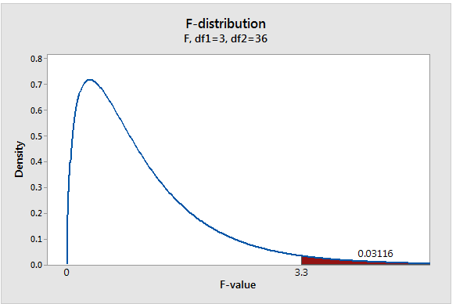
shaded area represents THAT probability
SICCOME F-values fall within this shaded region about 3.1% of the time when the null hypothesis is true.
ALLORA That probability allows us to determine how common or rare our F-value is under the assumption that the null hypothesis is true. $→$ If the probability is low enough, we can conclude that our data is inconsistent with the null hypothesis, that is, the evidence in the sample data is strong enough to reject the null hypothesis for the entire population.
This probability that we’re calculating is also known as the p-value!
This probability is low enough to reject the null hypothesis using the common significance level of $α=$0.05……………
….
https://blog.minitab.com/blog/adventures-in-statistics-2/understanding-hypothesis-tests-significance-levels-alpha-and-p-values-in-statistics

CONCLUSION
The higher the F-value the higher the variation of variation between sample (group) means than variation within the samples.
The F-statistic is the test statistic for F-tests (and incorporates both measures of variability discussed above). In general, an F-statistic is a ratio of two quantities that are expected to be roughly equal under the null hypothesis, which produces an F-statistic of approximately 1.
QUINDI TANTO PIU’ SONO LONTANO DA 1 TANTO PIU’ E’ MEGLIO PER IL MIO DATASET
A low F-value shows a case where the group means are close together (low variability) relative to the variability within each group. The high F-value graph a case where the variability of group means is large relative to the within group variability.
In order to reject the null hypothesis that the group means are equal, we need a high F-value.

DATO CHE IL RAPPORTO DI VARIANZE CHE VIENE SCELTO NELL’ANOVA E’ PROPRIO QUELLO CHE MI INTERESSA A ME PER CALCOLARE QUELLE METRICHE IL P-VALUE E L’F VALUE DICONO LA STESSA COSA IN QUANTO AUTOMATICAMENTE PIU VIENE GRANDE L’F-VALUE PIU IL P-VALUE E’ BASSO PER COME E’ DEFINITO
SE IL F-VALUE E’ PIU GRANDE E’ PERCHE’:
- E’ PIU GRANDE IL NUMERATORE
- E’ PIU PICCOLO IL DENOMINATORE
**significa che i rating attorno i valori medi del proprio group mean sono raccolti

CRITIC VALUE FOR F-VALUE
COME FACCIO A CAPIRLO? HO BISOGNO DI UN VALORE CRITICO CHE MI DICE QUANTO POSSO ACCETTARE L’ESSERE ABBASTANZA GROSSO PER L’F-VALUE
https://it.mathworks.com/help/stats/finv.html
(EXAMPLE MATLAB)
Find a value that should exceed 95% of the samples from an F distribution with 5 degrees of freedom in the numerator and 10 degrees of freedom in the denominator.
x = finv(0.95,5,10)
x =
3.3258
You would observe values greater than 3.3258 only 5% of the time by chance
LO FACCIO PER TUTTI E TRE GLI ATTRIBUTI CON I GIUSTI DEGREE OF FREEDOMS
NUMERATORE PRENDO df_columns
DENOMINATORE PRENDO df_errors
sarebbe come leggere qui ma non mi bastano le righe e colonne:
http://users.sussex.ac.uk/~grahamh/RM1web/F-ratio%20table%202005.pdf

$→$ Results WITH OUTLIERS

$→$ Results WITHOUT OUTLIERS

_________________________________________________

Percentiles and interquartile range. The median value is the value at which 50% of the observations are higher and 50% are lower. The median is also termed the 50th percentile or the second quartile. Percentiles divide the distribution into groups of specific sizes. The 25th percentile is thus the value at which 25% of the observation falls below and 75% falls above. The interquartile range is the difference between the 25th and 75th percentile

